**All about Mongodb**

**Open MongoDB URL :** [**https://www.mongodb.com/cloud/atlas/lp/general/try?utm_source=compass&utm_medium=product**](https://www.mongodb.com/cloud/atlas/lp/general/try?utm_source=compass&utm_medium=product)

**Configure Your Database using this simple steps**

**Database Access:**

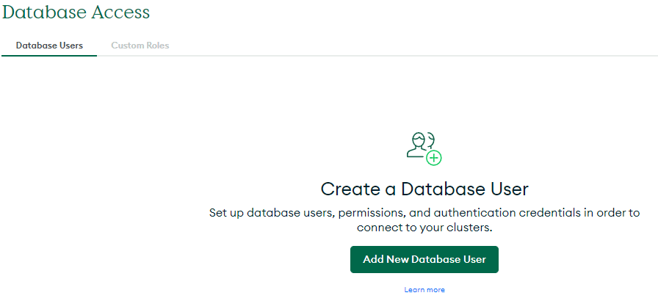

* **Click on “Add New Database User “**

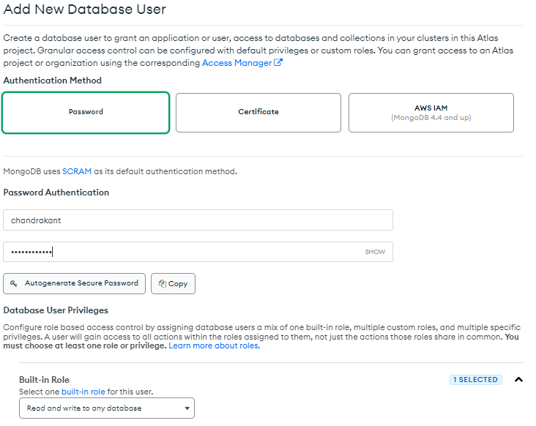

**Click on “Add User”**

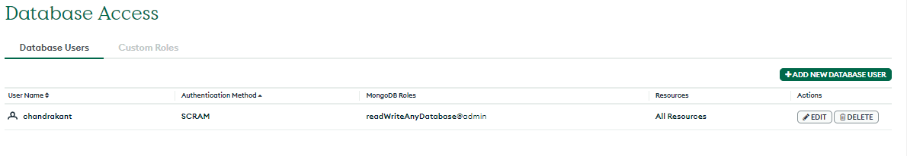

**Network Access**

**- > Click on “Add IP Address”**

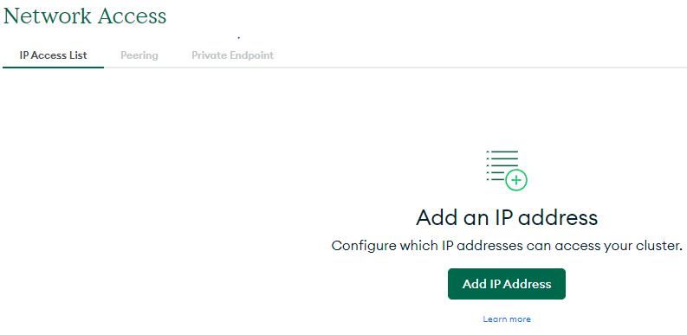

**Database**

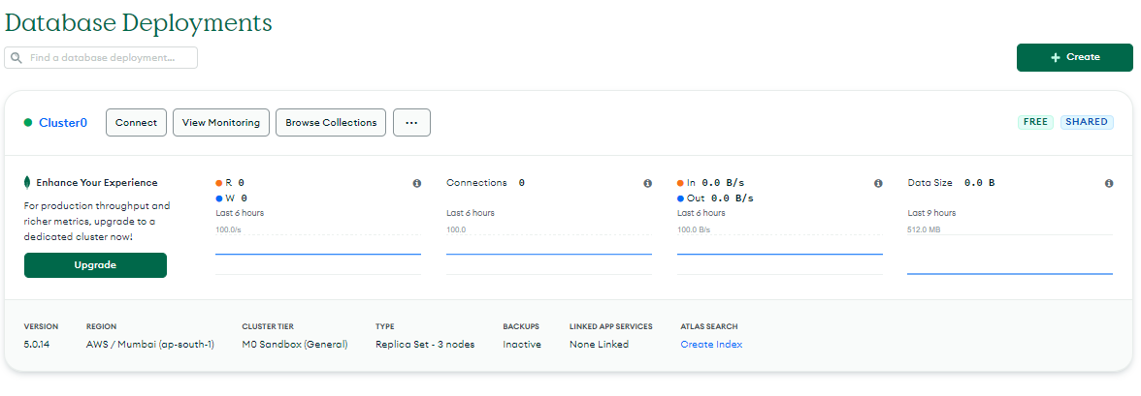

**Click on -> Connet Your Application**

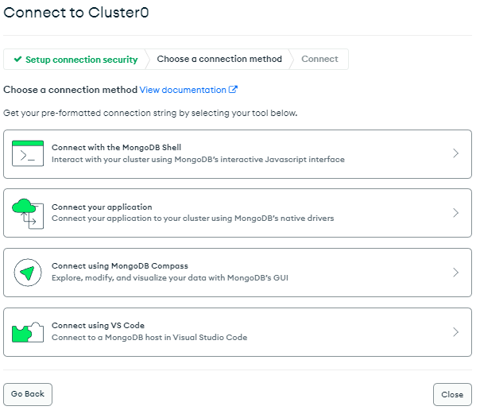

**Select Driver – Python**

**Version – 3.6 or Later**

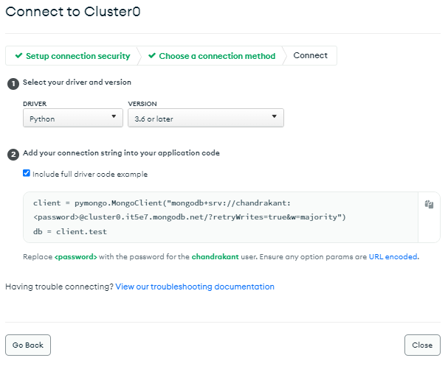

**In Jypyter Notebook**







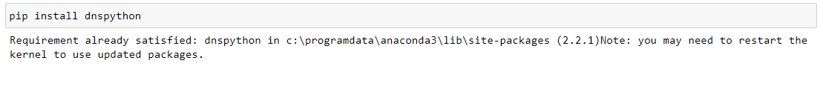

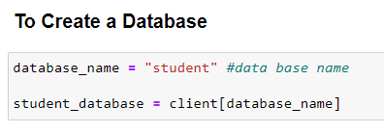

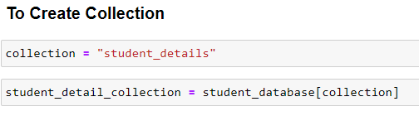

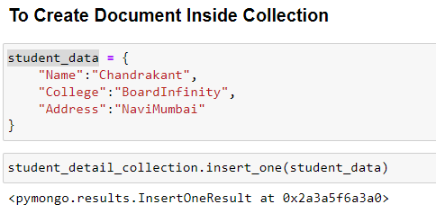

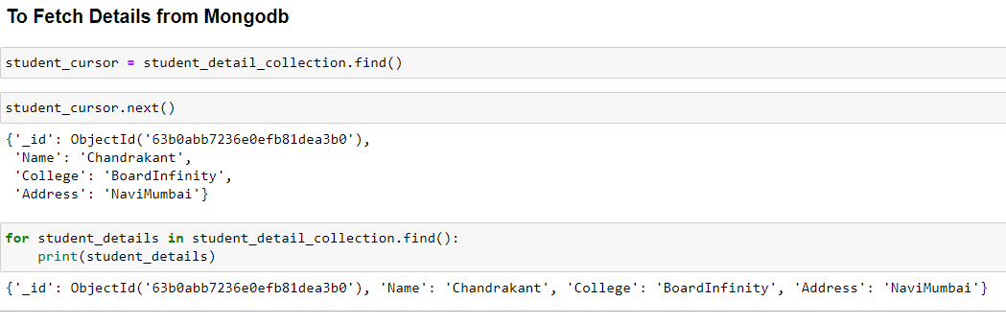

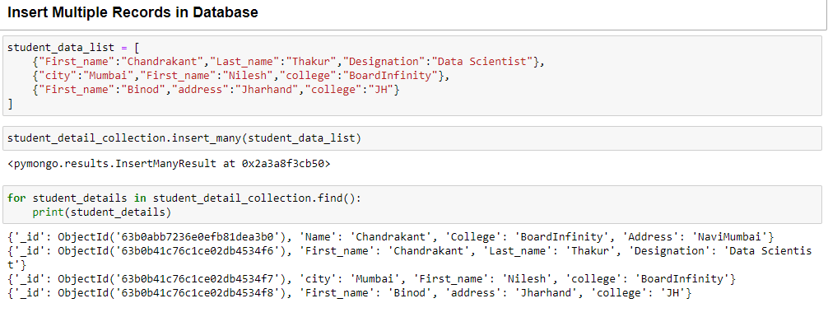

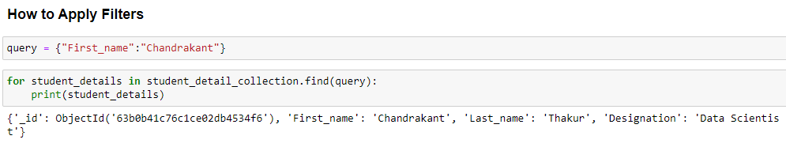

**Output:-**

**Final Output in Mongodb Atlas**

